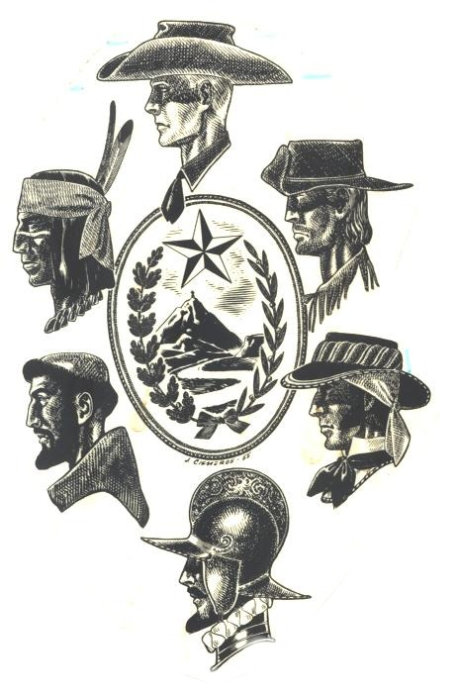
EL PASO COUNTY HISTORICAL SOCIETY
603 W. Yandell
El Paso, Texas 79902
(915) 533-3603
info@elpasohistory.com

2018 Hall of Honor Nomination Form

Each year, EPCHS selects living and deceased individuals considered to be outstanding men or women of character, vision, courage, and creative spirit. These individuals must have lived in El Paso County and have consistently done the unusual which deserves to be written or recorded, or have made El Paso County better for having lived in it. Each inductee is distinguished as having influenced over a period of years the course of history of El Paso County, or by their singular achievements have brought honor and recognition to the El Paso community and have directed us toward worthy goals and merit being remembered by all El Pasoans as an exemplary guide to our future.

Please submit this form to info@elpasohistory.com, attn.: Hall of Honor 2018, or mail this form to 603 W. Yandell, El Paso, TX 79902.

Nominator’s name _____________________________________ Phone # _____________

Relation to nominee ___________________ Email address ____________________________

*If selected, EPCHS will need to remain in contact with nominator and honoree (or individual accepting award on honoree’s behalf) while the event is planned.

Name of nominee: _____________________________________________

Name of closest living relative (if nominee is deceased):

___________________________________

Is nominee living or deceased? ______ Living ________ Deceased

Nominee’s address/address for closest living relative if nominee is deceased

Street number __________________________ Phone # _________________

City/State/zip code _____________________ Email Address ___________________________

Nominee birthplace _________________________ Nominee birthday___ _________________

Years of residence in El Paso _________________ Year range _________ to ____________

Biography of Nominee
Please include details of nominee’s achievements and works, especially those which took place in El Paso County. You may attach a biography to this nomination form, in lieu of using the space below.

______________________________________________________________________________

______________________________________________________________________________

______________________________________________________________________________

______________________________________________________________________________

______________________________________________________________________________

______________________________________________________________________________

______________________________________________________________________________

______________________________________________________________________________

______________________________________________________________________________

______________________________________________________________________________

______________________________________________________________________________

______________________________________________________________________________

______________________________________________________________________________

______________________________________________________________________________

______________________________________________________________________________

______________________________________________________________________________

______________________________________________________________________________

______________________________________________________________________________

______________________________________________________________________________

______________________________________________________________________________

______________________________________________________________________________

______________________________________________________________________________

